LINUX ASSIGNMENT (1 – 5)

ASSIGNMENT – 1:

WHAT HAPPENS WHEN YOU LOGIN A NON-EXISTENT USER OR USERNAME?

🡪 Typically, we will receive an error message indicating that the login has failed. The exact message may vary depending upon the LINUX distribution and the login method used (terminal or graphical interface like GNOME OR KDE).

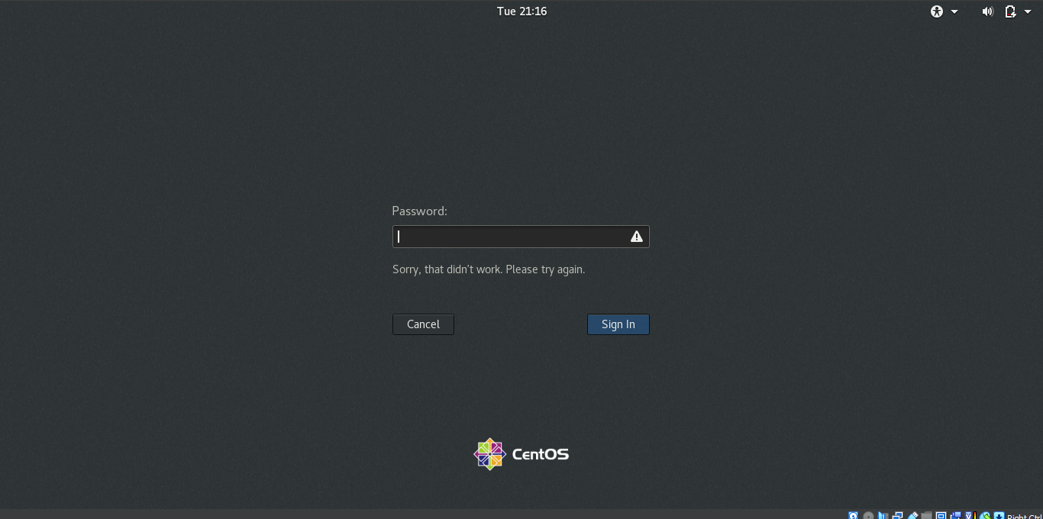

ASSIGNMENT – 2:

1. Login into your account and then change password? Change your password into IneuR0n#42 and hit the Enter key.

* In order to change the password, first we need to open our LINUX terminal and type the command:

**PASSWD**

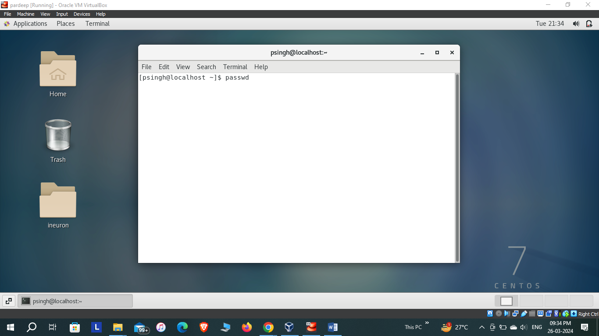

* Next, we are prompted to enter the current user password.

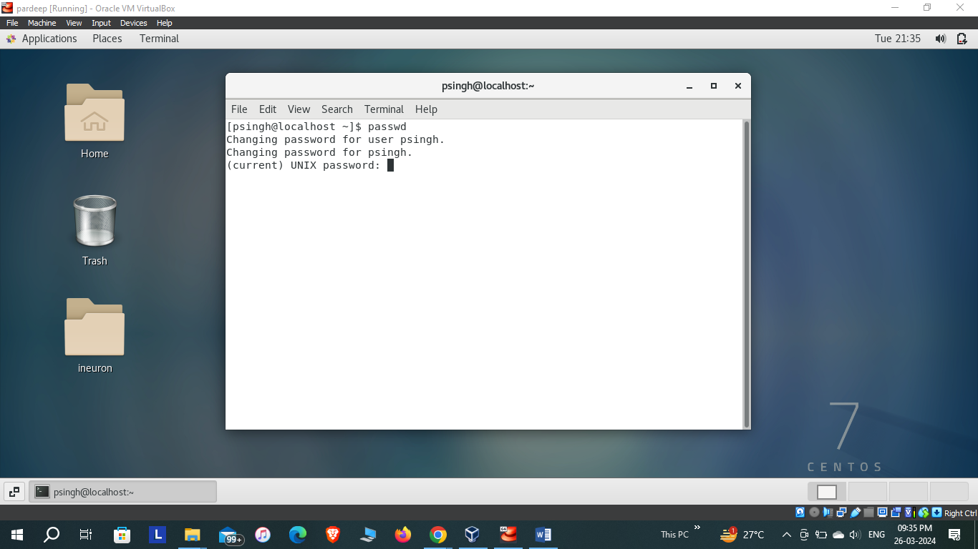

* Next, we are asked to enter the new password. While typing, the new password will not be visible to us due to security reasons. Followed by confirmation of password.

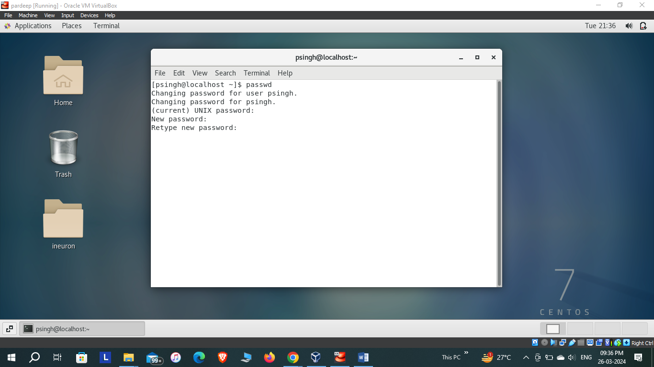

* Password will be changed.

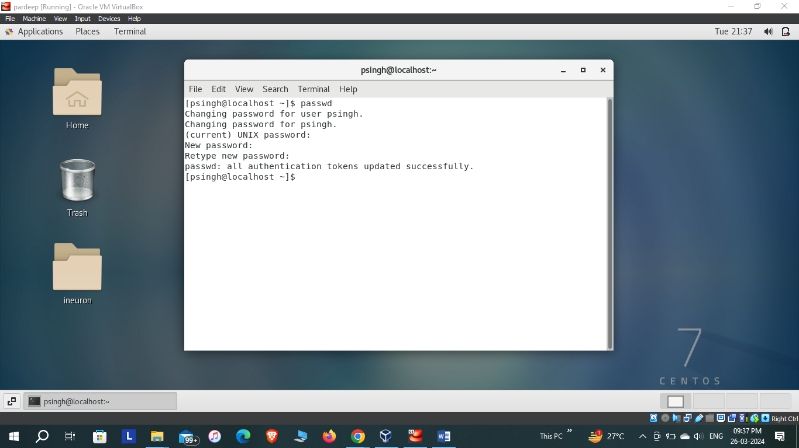

1. Try again to change password but use like password 1234 or abcd.

🡪The length of password must be atleast 8 characters. Therefore, password could not be changed.

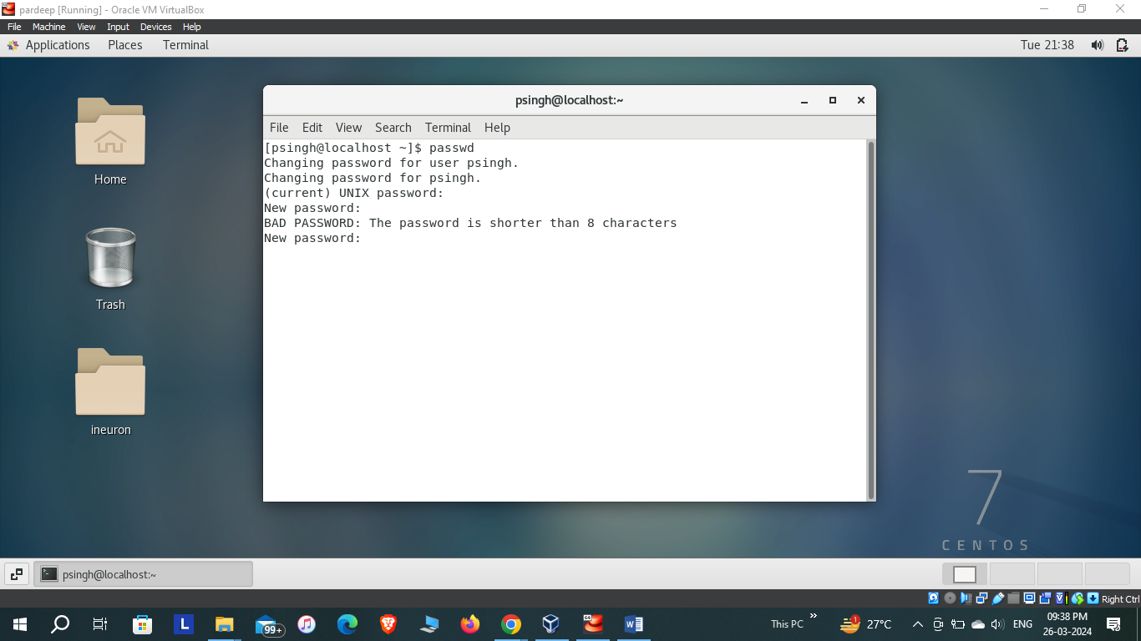

1. Try again to change password but now don’t use any password just hit Enter key.

🡪Terminal displays message: Np password supplied.

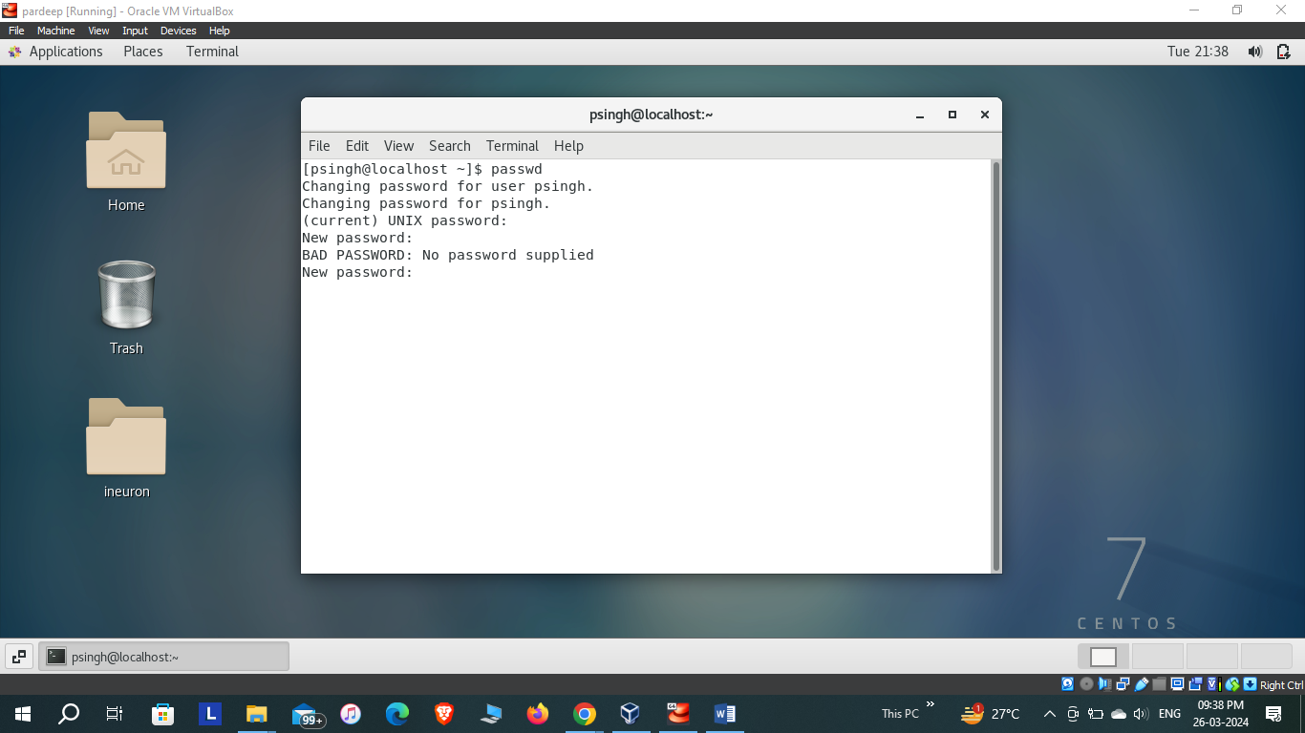

ASSIGNMENT – 3:

1.Enter the command cd / and then ls and then hit Enter key. Take screenshot and explain what output we got?

🡪The cd / command takes us to the root directory. Then, the ls command displays all the directories present in the root directory.

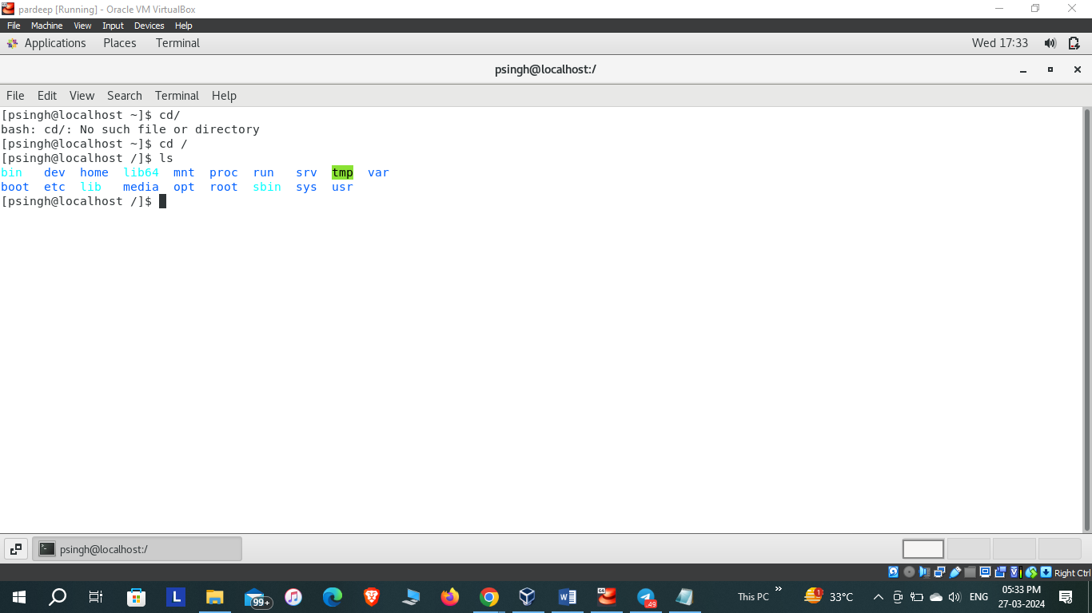

2.Enter the command now cd /home and then hit Enter key. Do ls, provide screenshot and explain what is /home directory used for?

🡪The **cd /home** command changes location to home directory. The **ls** command displays the user directories present in home directory.

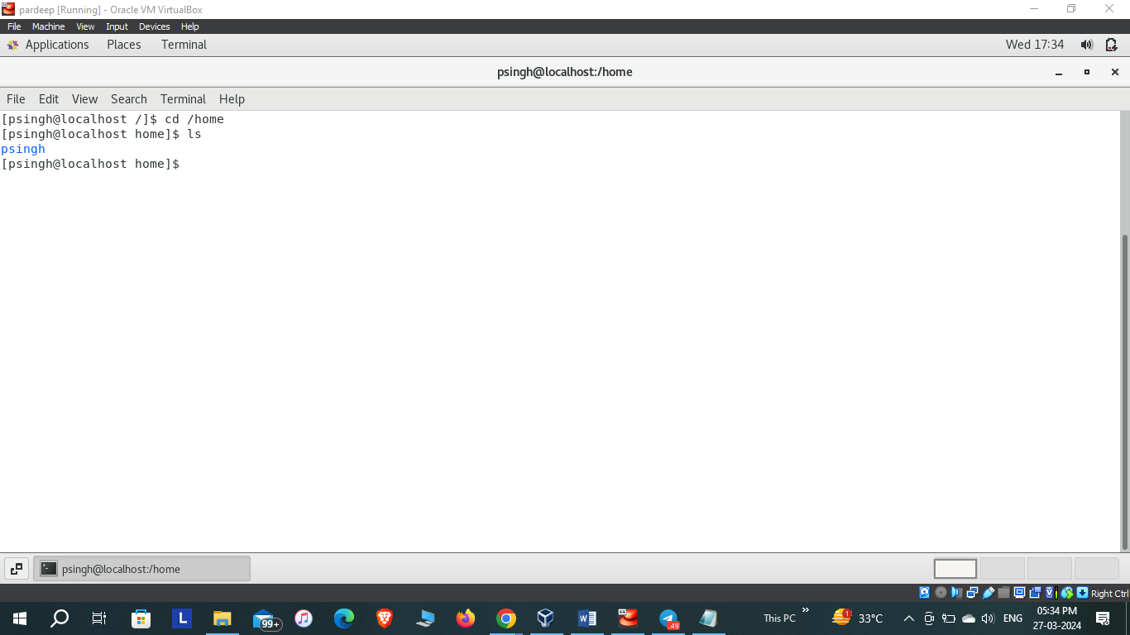

3.Enter cd .. and hit Enter key [ Note: here we have space after cd then use double dot]. Check what happen and give screenshot?

🡪 The **cd ..** command changes the location to a directory which is higher in the file system hierarchy than the present directory.

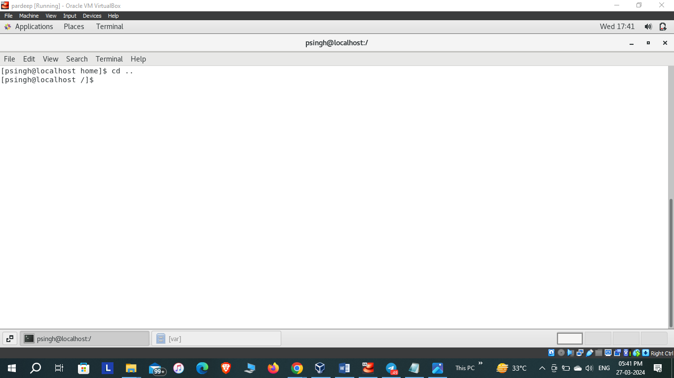

1. Now enter cd /var/www/html and then type cd and hit Enter key. Explain what happen and give screenshot?

🡪 There is no such directory as **www** present inside the **var** directory so the terminal displays the message: no such file or directory.

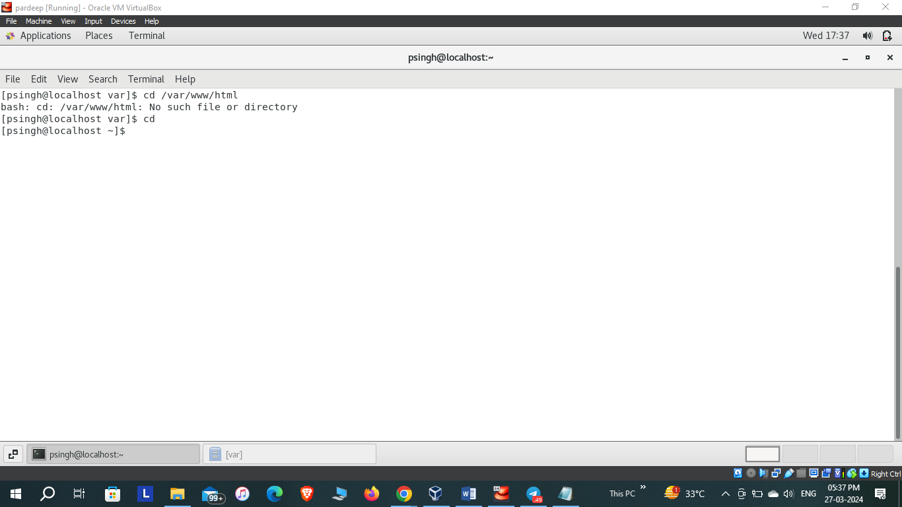

1. Now type cd /root and then hit Enter key. Do ls, check any output we have on screen if yes then take screenshot?

🡪The access to the root file is denied.

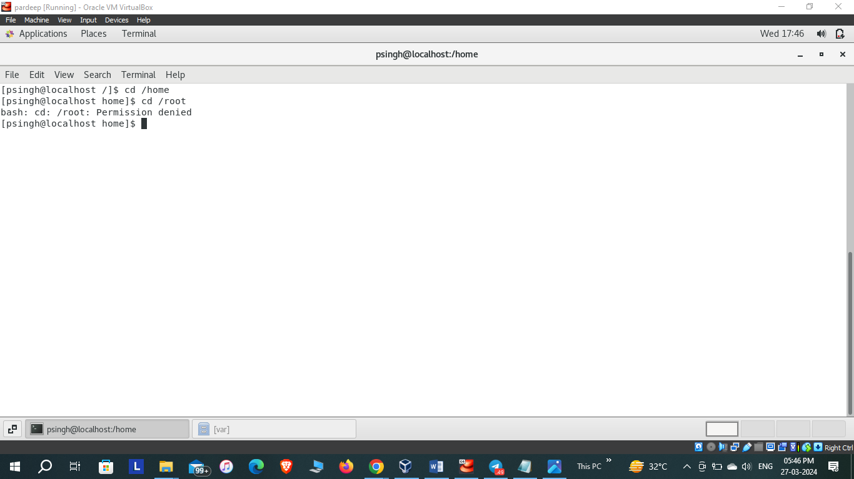

ASSIGNMENT – 4:

1. Go to cd /etc and type ls. Take screenshot and explain what files you have seeing?

🡪The **/etc** is a crucial directory in Unix-like operating systems that stores system wide configuration files and setting. The **ls** command typically displays the various configuration files and directories used by the system and installed softwares.

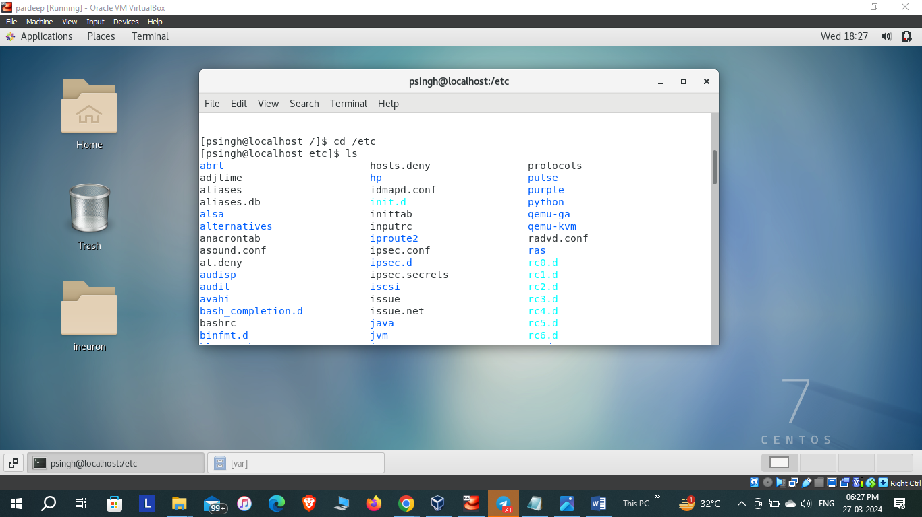

1. Then type ls -al and hit Enter key. Take screenshot and explain what new file or directory you found?

🡪The command **ls –ai** lists all the files and directories in the current directory, including the hidden files, and display their **inode** number alongside their names.

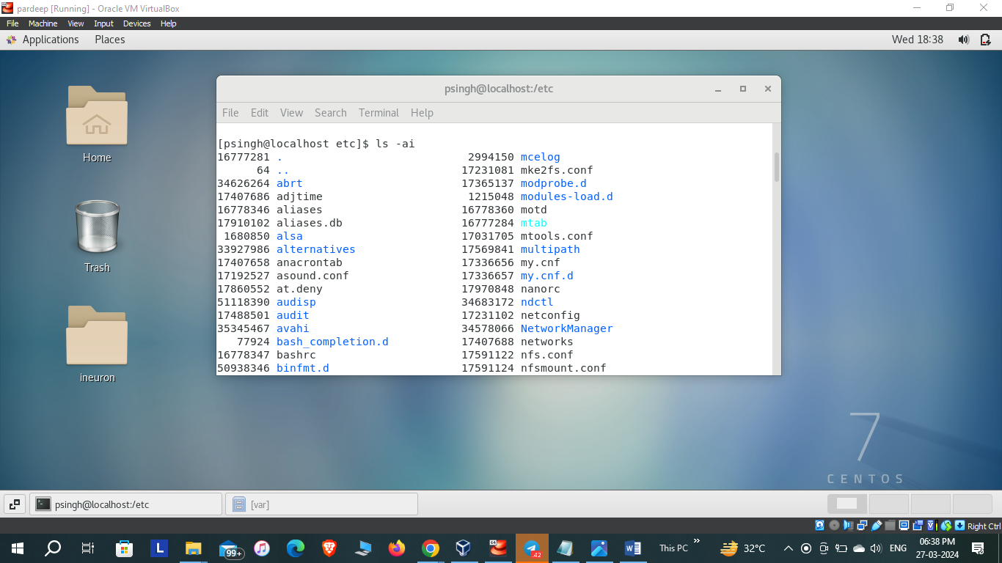

1. Then use ls -i and hit Enter key. Now see what different output its shows and take screenshot?
2. 🡪The **ls -i** command displays the files or directories present in the present directory(except the hidden files) along with their **inode** numbers.

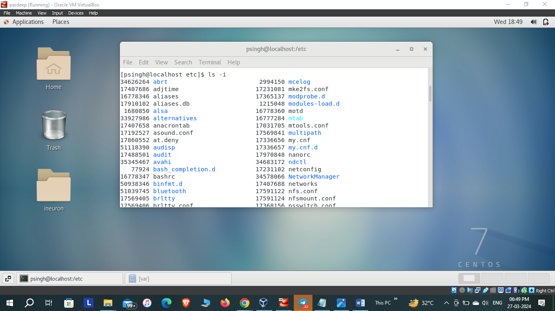

ASSIGNMENT – 5:

1. Open terminal after restart the LINUX. Check which location you working, type **pwd** and take screenshot.

🡪**pwd** stands for ‘print working directory’, it displays the full path of the current working directory. After restarting the LINUX, the command displays the full path of the user directory.

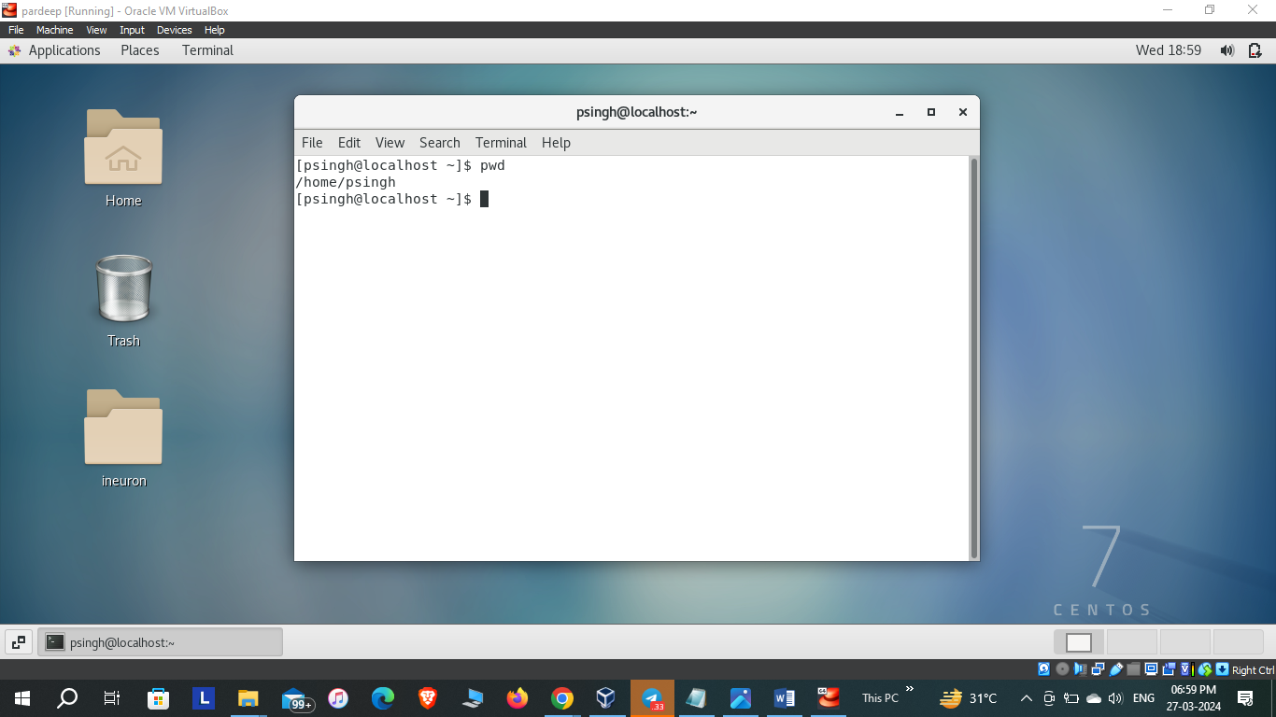

1. Now use cd /var and hit Enter key. Do ls, and see what output comes, give screenshot?

🡪The **cd /var** command changes the directory to **/var**. The **ls** command displays the content of the **/var** directory, which includes the temporary files, spool files, log files and other data files used by the system and applications.

